Decision Tree Using iris Data

Assignment 12

Submitted by:

Group 4

**What is a decision tree?**

A decision tree is a tool that builds regression models in the shape of a tree structure. Decision trees take the shape of a graph that illustrates possible outcomes of different decisions based on a variety of parameters. Decision trees break the data down into smaller and smaller subsets, they are typically used for machine learning and data mining and are based on machine learning algorithms.

**Decision tree using ‘party’ package**

‘party’ is used to create decision trees in ‘R’.

**Steps:**

1. **Install ‘party’**

‘party’ package can be downloaded using given syntax:

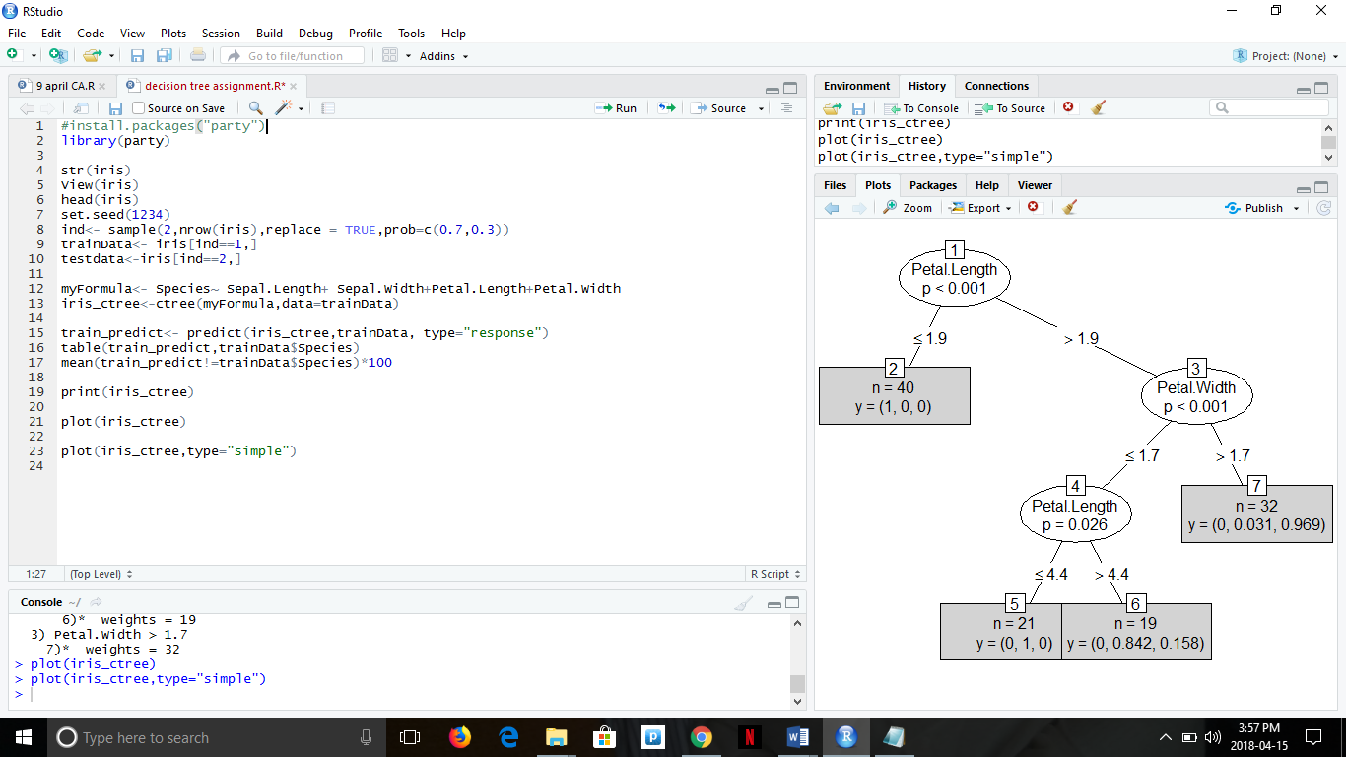

1. **View data:**



**Head view:**

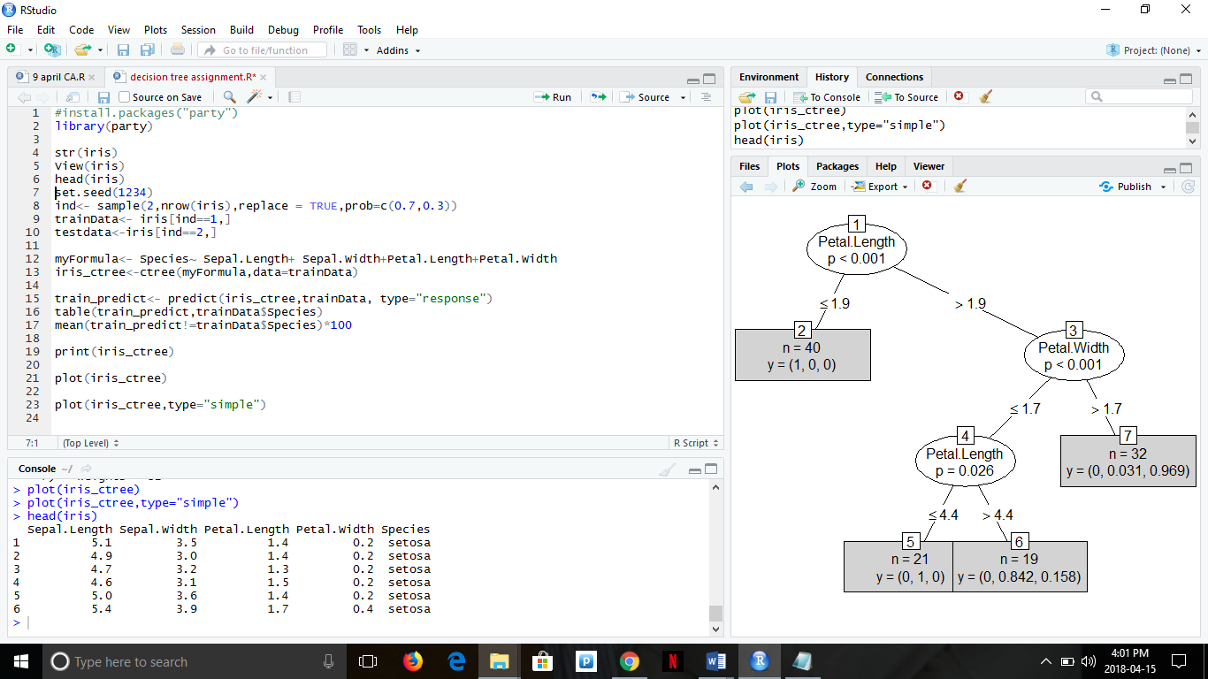

1. **Use of ctree function to create decision tree:**

In the code below, myFormula species that Species is the target variable and all other variables are independent variables.

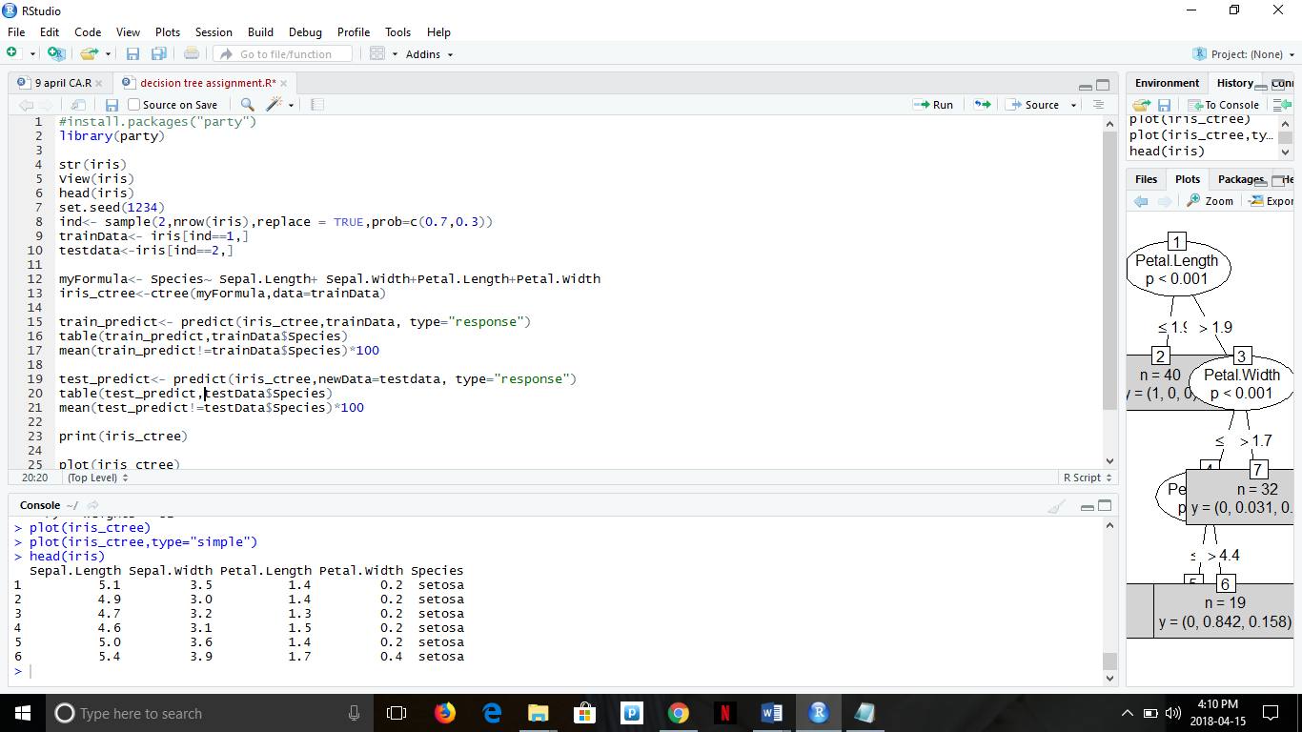

1. **Print ctree data:**

We can look into the model and do some plot to better understand the model.

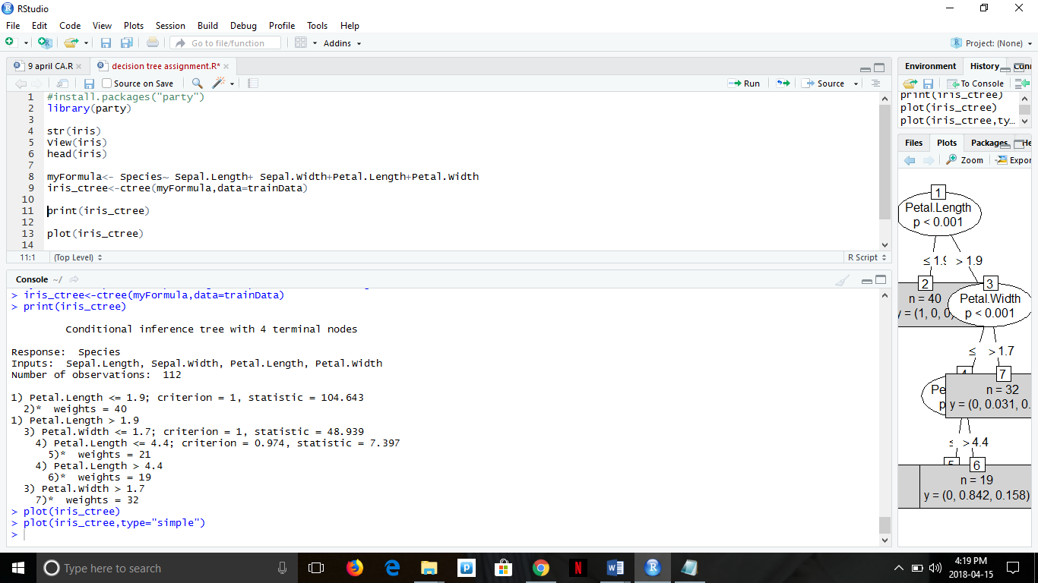

1. **Plot of decision trees:**

**First plot:**

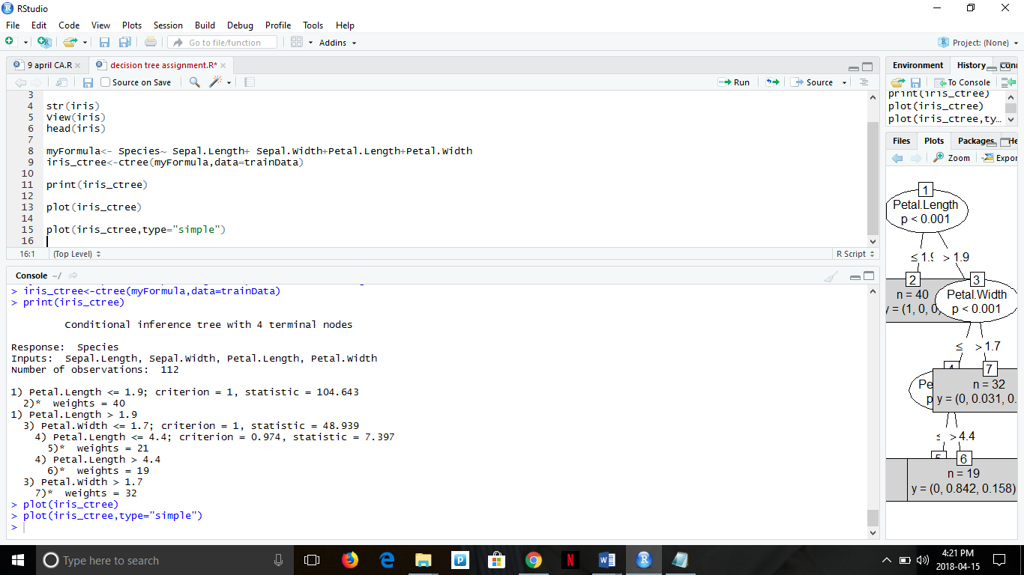

**Output:**

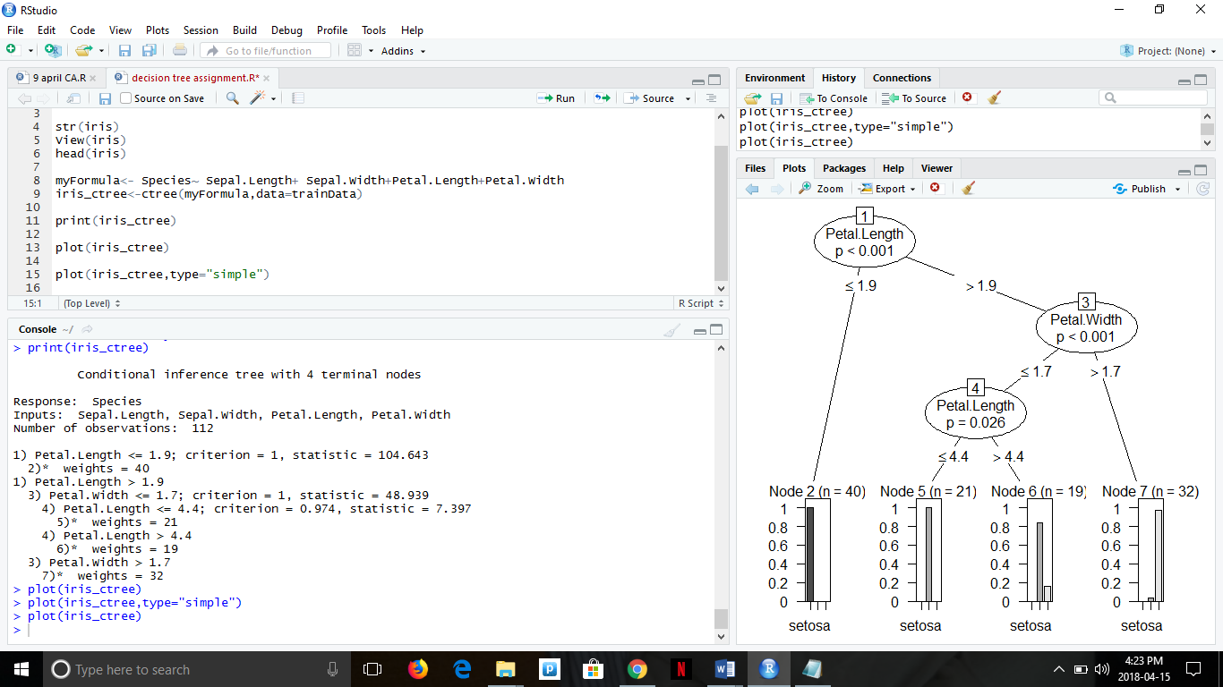

**Second plot:**



**Output:**

